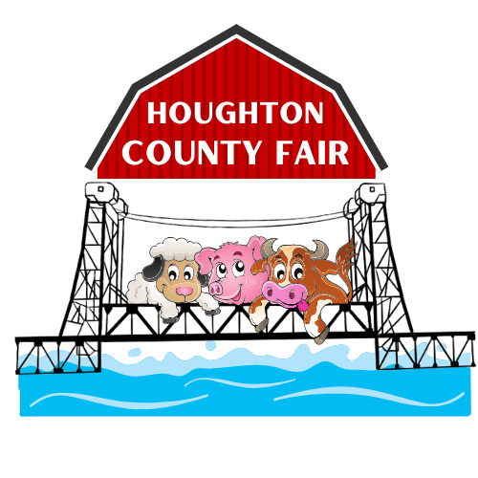
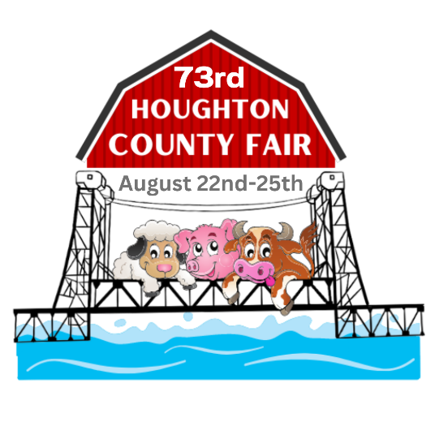
Houghton County Fair
72nd
AUGUST 24th-27th

1500 Birch Street, Hancock, MI 49930

Phone (906)482-6200

www.houghtoncountyfair.com
houghtoncountyfair@hotmail.com

December 20, 2024
2024 Year End:

- The 2024 Houghton County Fair was very successful! Attendance was estimated at 22,080 individuals over the 4 days of the fair. This was down slightly from last year, which was a record breaking year.

- There were 92 adult exhibitors and 166 youth exhibitors. The fair had 2550 exhibits overall. That was up by about 100 exhibits from last year. Premiums paid out amounted to $12,983. Exhibitors included 37 Houghton/Keweenaw County youth that participated in the Junior Market Livestock Program and sold their beef steers, hogs and lambs for a total of $131,000. Livestock sold back at market price or donated back to the fair for the livestock program generated approximately $7000, which helps to pay expenses and for improvements to the livestock area of the fair.

- There were 117 registered volunteers throughout the fair, donating a precious commodity, their time. This included board members, superintendents, clerks, judges, those putting on races and derbies. The support of the community in the form of volunteers and monetary donors, and with the help of Houghton County, the City of Hancock, H/K 4-H, area police and fire departments, local media, and local businesses donating the use of equipment or other in-kind services are essential to put on the fair. There were a total of 77 businesses and individuals that were sponsors. Thanks to Michigan legislators and the MDARD for allocating the funds for capital improvements used to build the addition to the exhibit building, and Phil Ruppe (and in memory of Loret) for matching funds.

The 2025 Houghton County Fair - August 21st to the 24th

- Next year’s professional entertainment lineup will include Skerbeck Entertainment Group, Monster Truck Throwdown, the Sea Lion SPLASH, Alfy’s Robotic Puppets, Kerry Sharp – Hypnotist, and Whispering Pines Mobile Zoo. The fair has contracted with TNT Demolition Derby which will handle all aspects of the Derby, which will be held on Friday night this year. There will be separate contests for bonestock cars, small cars, mini-vans and Powerwheels for kids! All of the rules are on their website, www.tntderby.com.

- Local entertainment will include Motocross Races on Thursday night. Senior Citizen’s Day will be Friday, as well as Livestock shows. The Youth Talent Show and the Livestock Auction will be on Saturday, and Cattle Sorting is tentatively planned for Saturday. The fair will conclude Sunday with the OFF ROAD Derby. Check HoughtonCountyFair.com as more information becomes available.

