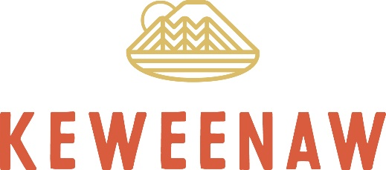
Visit Keweenaw
56638 Calumet Avenue Calumet, MI 49913
Phone: (906) 337-4579 Fax: (906) 337-4285
Website: www.visitkeweenaw.com
Email: info@visitkeweenaw.com

NEWS
FOR IMMEDIATE RELEASE
Media Contact: Jesse Wiederhold
Visit Keweenaw
(906) 299-4444; jesse@visitkeweenaw.com

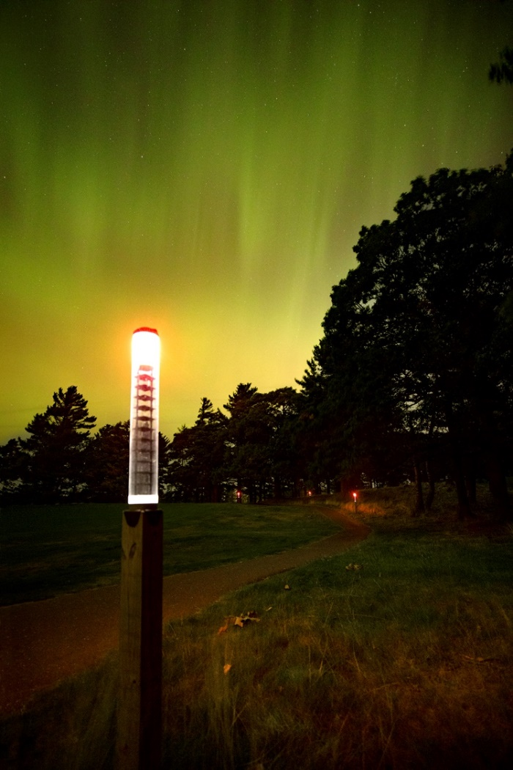
Illuminate the Night: Follow This Glowing Red Path to See Stars in the Keweenaw
Follow these red lights to find the aurora at the Keweenaw Dark Sky Park in Copper Harbor. (Chris Guibert)
COPPER HARBOR, Michigan (Nov. 4, 2024) — In Michigan’s Keweenaw Peninsula, stargazers have a way to wander the nightscape. This winter, the Keweenaw Dark Sky Park at the Keweenaw Mountain Lodge in Copper Harbor has a gently glowing, crimson trail that leads to prime areas to see the stars. You will be able to see the Milky Way arch overhead and constellations like Orion sharpen as your eyes adjust – and possibly the Northern Lights.

Using red lights does not burn up rhodopsin in your eyes like white lights. That is what allows us to see in the dark. The red lights softly illuminate the path only when motion is detected, guiding you safely to four designated Night Sky Viewing Areas in the dark sky park where you can settle in and enjoy the show of the universe. With longer, darker nights holding on for winter—your chance of seeing the aurora is going up every day. With the path specifically designed to minimize environmental impact, each light recharges by solar power, powered by the sun during the day and softly lighting the way by nightfall.

The lights are crafted by University of Michigan Professor Mojtaba Akhavan-Tafti, who founded APT Solar Solutions. They represent not just an innovation in stargazing, but a connection made through the Keweenaw Mountain Lodge’s involvement with the MEDC’s Office of Future Mobility & Electrification. Akhavan-Tafti was able to visit the Keweenaw and help with the installation of the red solar lights – testing out his product in some of Michigan’s snowiest, darkest territory.

“Our mission at APT Solar Solutions is to bring clean electricity to the four corners of the Universe,” said Mojtaba Akhavan-Tafti, Founder & CEO of APT Solar Solutions. “We partnered with the Keweenaw Mountain Lodge to pilot our solar lighting fixtures, further supporting their dark-sky initiatives. Since the installation in 2023, our solar lights have reliably lit up the wooded paths at the lodge in all weather conditions and snow cover, helping to bring the sky closer to stargazers, and lodge guests alike. It has been great working with such an environmentally-focused and innovative organization.”

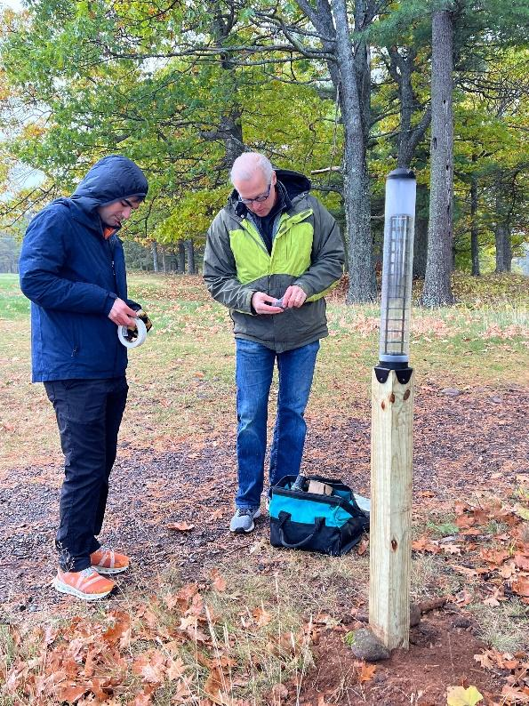
Imagine standing at the edge of a place that feels like another world – a real-life twilight zone. Arrive to the red-light trail and zip up your coat. The night sky is alight with the swirling greens of the aurora borealis, each ripple and wave shift in a cosmic dance. It feels otherworldly, as if you’ve just stumbled into a boundary where the earth and sky connect. The red light path guides you past silhouetted trees, drawing you to the electric energy of the stars. It’s a place where reality meets wonders after the sun sets, pulling you into a realm where nature feels supernatural and your can live out your dark sky dreams. Come see the Keweenaw Dark Sky Park at the Keweenaw Mountain Lodge soon and get familiar with the grounds before you need snowshoes to get around!
Akhavan-Tafti was able to visit and help with the installation of the solar lights. (Chris Guibert)

The Keweenaw Mountain Lodge is hosting a Night Sky Photography Workshop on Dec. 28 in the Dark Sky Park. And tickets also just went on sale for the 2025 Upper Peninsula Dark Sky Festival for folks looking to spend a few days in the park April 24-26, 2025.

