
Visit Keweenaw
56638 Calumet Avenue Calumet, MI 49913
Phone: (906) 337-4579 Fax: (906) 337-4285
Website: www.visitkeweenaw.com
Email: info@visitkeweenaw.com

NEWS
FOR IMMEDIATE RELEASE
Media Contact: Jesse Wiederhold
Visit Keweenaw
(906) 299-4444; jesse@visitkeweenaw.com
Imagery Download (Visit Keweenaw)
Winter What?!: Win Free Swag by Forecasting Michigan’s Northernmost Snow Total
THE KEWEENAW, Michigan (Nov. 6, 2024) — Take your best guess at how many inches of snow will blanket the Keweenaw Peninsula this winter and win free swag. Visit Keweenaw is inviting the public (Yoopers, Trolls and beyond) to take a stab at how much of the white stuff is falling this season. Sign up via the Google Form, and see how your guess stacks up at the end of the season. Visit Keweenaw will publicly announce a winner this year, giving you bragging rights and free Visit Keweenaw swag if your guess matches the season results.

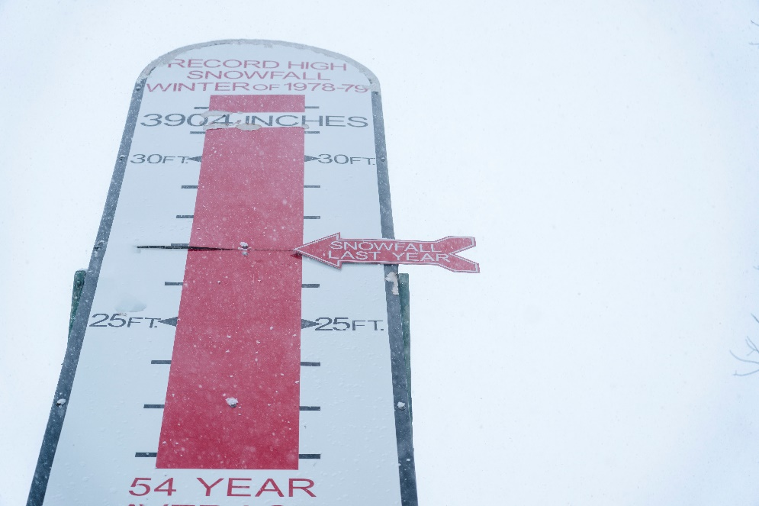
If any one spot in Michigan gets belted with snow during winter, it’s typically the Keweenaw. With high elevation across the rugged Peninsula, strong winds off Lake Superior and its northern latitude, the Keweenaw is no stranger to 300-inch winters. In fact, the highest amount of snowfall on record was 390.4 inches (32.5 feet) during the winter of 1978-79. The lowest ever was in 1930-31, where only 80 inches of snow fell over winter. Last year’s winner hit the mark – guessing a below average winter at 126.5 inches. With changing weather patterns, most forecasters are calling for more snow than last year – looking promising for winter sports enthusiasts.
A weather gauge in the Keweenaw shows the region's historical snowfall records. (Visit Keweenaw)

While no one can predict the exact amount (or maybe you can), every guess brings a bit of fun competition to the season! Visit Keweenaw encourages everyone to join the challenge, whether they’re dreaming of deep powder for snowboarding or just looking to cozy up by a fire.

To participate, simply enter your prediction on the Google Form before Dec. 13, 2024 at 5 p.m. At the end of the season, the Visit Keweenaw team will announce a winner. The winner will be able to pick up their swag from the Visit Keweenaw office or make mailing arrangements. So, snow lovers and skeptics alike, gear up and take your shot at Michigan’s most epic snow forecast. Visit Keweenaw uses Keweenaw County’s snowfall reporting to run its contest. Sometimes, it snows as late as May – so stay tuned until the season concludes.
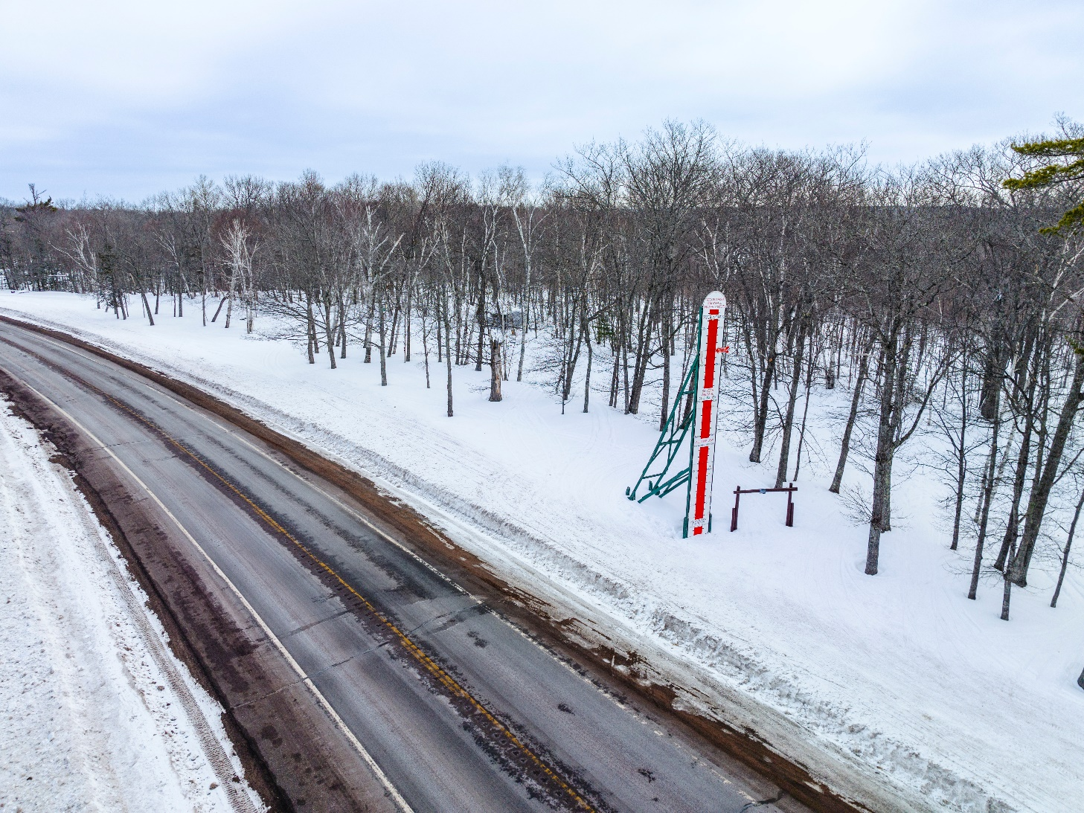
How much snow will we get this year? (Visit Keweenaw)

