
Eastern Region

Forest Service News Release
Press Officer: Sharon Stiteler
sharon.stiteler@usda.gov
www.fs.usda.gov/r9

USDA Forest Service Advises to Lookout for Zombie Trees

These seemingly alive trees could be a danger to your home or brains.
Milwaukee, WI (October 29, 2024) — This Halloween, as leaves begin to turn colors and fall from trees, is the time to watch out for a scary threat you might find in your yard – zombie trees.
In true zombie fashion - zombie trees look alive but are actually dead or dying on the inside. And like real zombies, zombie trees are hazardous to the living and their braaaaaaains. Weakened limbs or an entire tree can fall unexpectedly, causing serious injuries, or damage to property.
So, what is killing these trees from the inside out? Likely insects or disease. You might be able to spot a zombie by seeing dying branches, noting leaf discoloration or leaves dropping earlier than normal. You might also have increased woodpecker activity, or it might be as obvious as seeing exposed internal decay or fungi growing on the tree.
While zombie trees and dead trees in the forest create valuable habitat for cavity-nesting birds and mammals, in an urban environment they pose a safety hazard.
If you suspect that you have a zombie in your yard. First, scream. Then, contact a professional arborist to inspect the tree and suggest treatment options or removal. In some cases, the arborist may be able to recommend insect and disease treatments that can restore your tree’s health. Treatments may be as simple as pruning dead branches or fertilization.
The USDA Forest Service’s Trees Owner’s Manual is a great resource on how to plant a tree and includes tips for caring for your trees, including how to hire an arborist.
Stay safe out there and keep an eye out for zombies.

-END-
Grounded in world-class science and technology - and rooted in communities - the U.S. Department of Agriculture Forest Service connects people to nature and each other. As a federal agency in service to the American people, the Forest Service cares for shared natural resources in ways that promote lasting economic, ecological, and social vitality. In doing this, the agency supports nature in sustaining life. To learn more about the Forest Service, visit Home | US Forest Service (usda.gov)

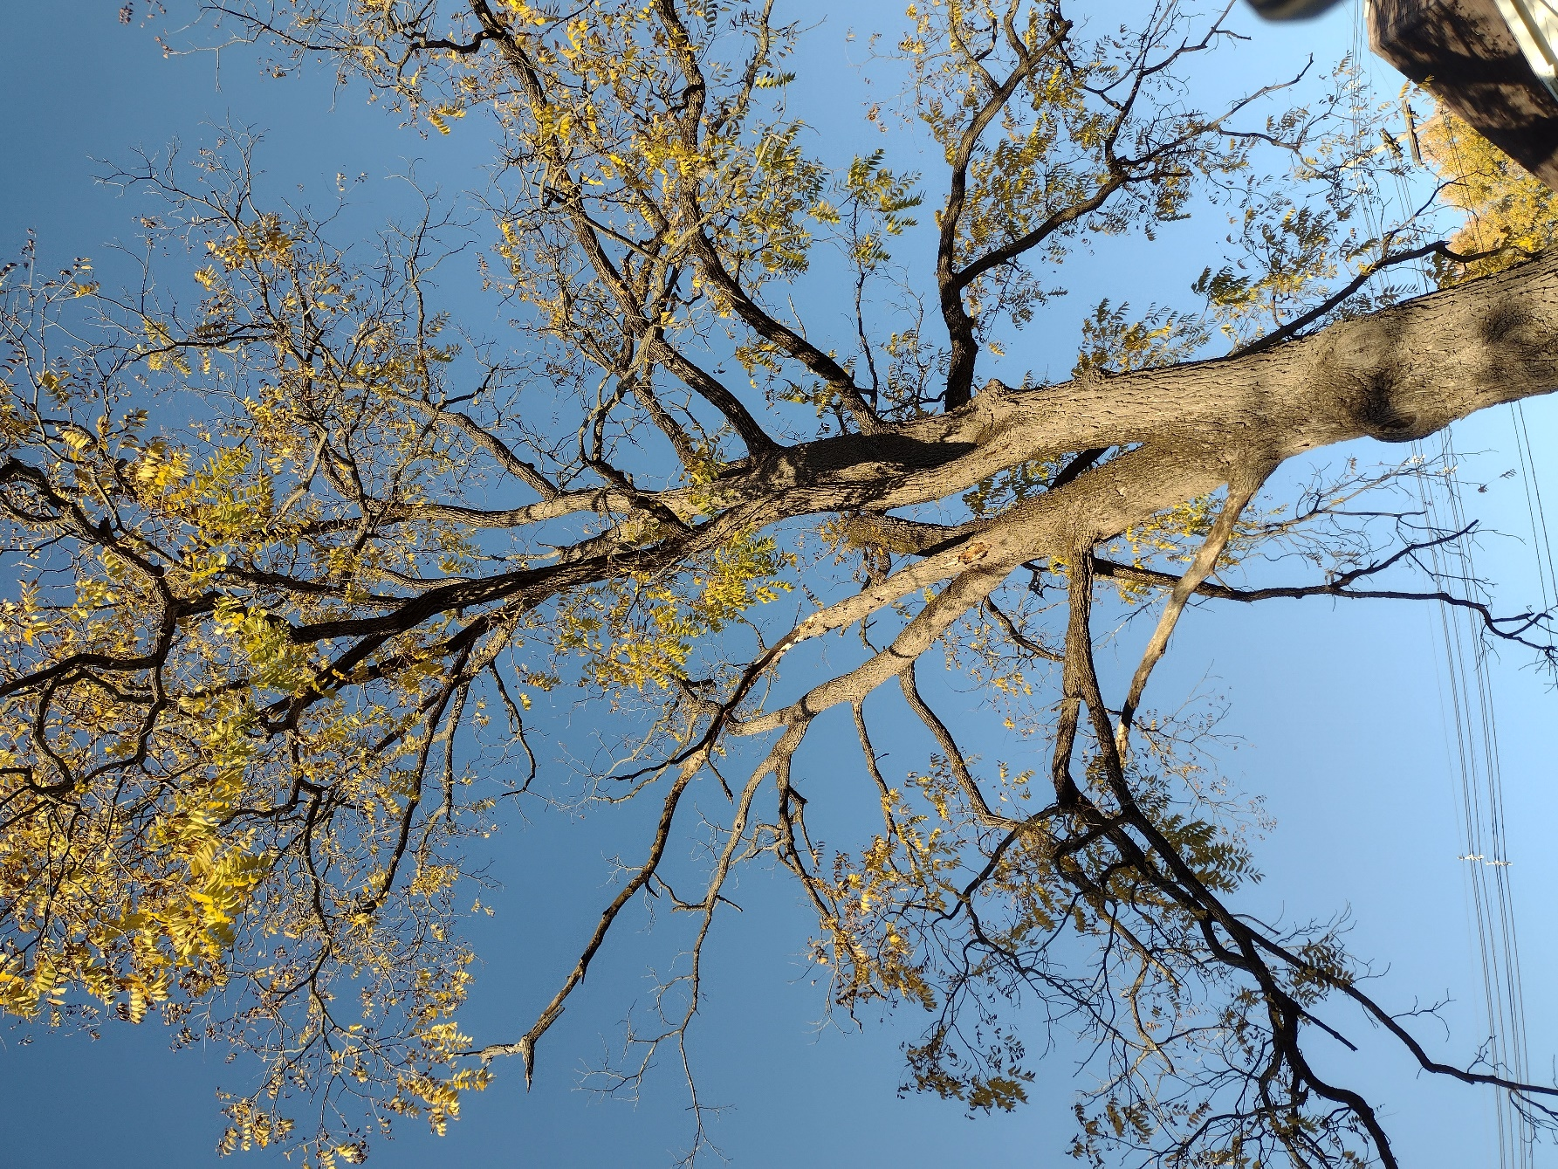
Example of a tree exhibiting “zombie” effects. Photo USDA Forest Service/Devin Wanner.

