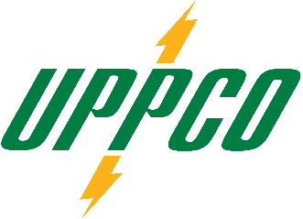

FOR IMMEDIATE RELEASE
Page 1 of 1


www.UPPCO.com
CONTACT: Dan Freeborn October 25, 2024
OFFICE: (906) 232-1422
CELL: (906) 250-6474
EMAIL: dfreeborn@uppco.com

EARLY DRAWDOWN PLANNED FOR VICTORIA RESERVOIR STARTING OCTOBER 28th
EARLY TIMELINE REQUIRED TO SUPPORT PLANNED FACILITY IMPROVEMENTS

Marquette – Upper Peninsula Power Company (UPPCO) is announcing the Victoria Reservoir will be undergoing an early drawdown to support an ongoing maintenance and powerhouse facility improvement project. The drawdown will begin on Monday, October 28, 2024, and will lower the reservoir level over several days.
UPPCO is also reminding the public to be safe whenever recreating near the company’s hydroelectric facilities and to obey all posted warning signs.

###
For more information about UPPCO visit www.uppco.com
UPPCO is the Upper Peninsula’s largest electric utility serving approximately 52,000 customers across 4,460 square miles. UPPCO and its predecessors have excelled at providing dependable service and safe, reliable energy to its valued customers for more than 135 years.

