Contact:
Anne Kretschmann
Houghton/Keweenaw County 4-H Program Coordinator
906-482-5830
Kretsc11@msu.edu

For Immediate Release

Houghton-Keweenaw County 4-H Youth Awards Ceremony

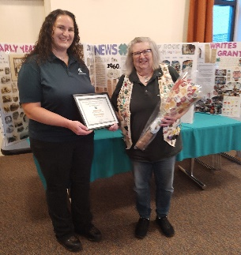
Photo Caption: 2024 Alumni of the Year awardee and centennial club Trap Rock 4-H Club leader, Joan Dostaler, receives her award from Houghton-Keweenaw County 4-H Program Coordinator Anne Kretschmann.
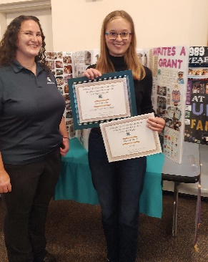
Photo Caption: 2024 Up and Coming 4-H’er of the Year awardee, Aleah Simpson, receives her award from Houghton-Keweenaw County 4-H Program Coordinator Anne Kretschmann.
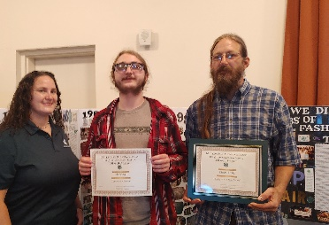
Photo Caption: 2024 Houghton-Keweenaw County 4-H Family of the Year recipients, the Olson family were honored for their dedicated involvement in 4-H.

Outstanding Houghton-Keweenaw 4-H members, volunteers, and supporters gathered for the annual awards ceremony hosted by the Houghton-Keweenaw 4-H Council in October to celebrate the youths’ accomplishments. During the event, youth received certificates and pins in recognition of their achievements through 4-H. The award categories showcased the diverse array of 4-H knowledge, skills, and experience.
The highlight of the evening was the 4-H Alumni of the Year, Joan Dostaler’s showcase of the Trap Rock 4-H Club, which is celebrating its 100 year centennial! Club members and leaders prepared a 100 year tribute that was displayed at the fair, awards ceremony, and in the community. The Trap Rock 4-H Club is one of the longest continually meeting 4-H clubs in the nation! Houghton-Keweenaw 4-H was excited to celebrate this milestone with the club. “The Trap Rock 4-H Club has met more regularly and done more community service over the years than any other club in the Keweenaw”, says Anne Kretschmann, Houghton-Keweenaw County 4-H Program Coordinator, “They are truly dedicated to making a difference in their community and world.”
We are excited to announce that Aleah Simpson, a member of the local Country Living 4-H Club was chosen as the awardee for the 2024 Up and Coming 4-H’er of the year, an award given to a first year 4-H member who had an exceptional year. “We congratulate Aleah for her eagerness to learn new things and to do her best, indeed to make the best better!”, says Kretschmann.
The Olson family was recognized as the Houghton-Keweenaw 4-H Family of the Year. This award is given to a family that exemplifies the principles of 4-H in their lives. The Olson’s enthusiastically participate in Country Roots & Dirty Boots 4-H Club’s community service and fair projects. Riley has learned skills through 4-H that he is taking to the next level with animals and gardening. “Riley and Nate have truly exemplified what a 4-H success story looks like”, says club leader Lori Stingle.
To learn more about 4-H opportunities in the area please contact the Michigan State University Extension office at (906) 482-5830.

MSU is an affirmative-action, equal-opportunity employer, committed to achieving excellence through a diverse workforce and inclusive culture that encourages all people to reach their full potential. Michigan State University Extension programs and materials are open to all without regard to race, color, national origin, gender, gender identity, religion, age, height, weight, disability, political beliefs, sexual orientation, marital status, family status, or veteran status.
--END--

