The Nature Conservancy provides Heartlands Update to community
TNC continuing to lay groundwork for local management and governance of the Heartlands
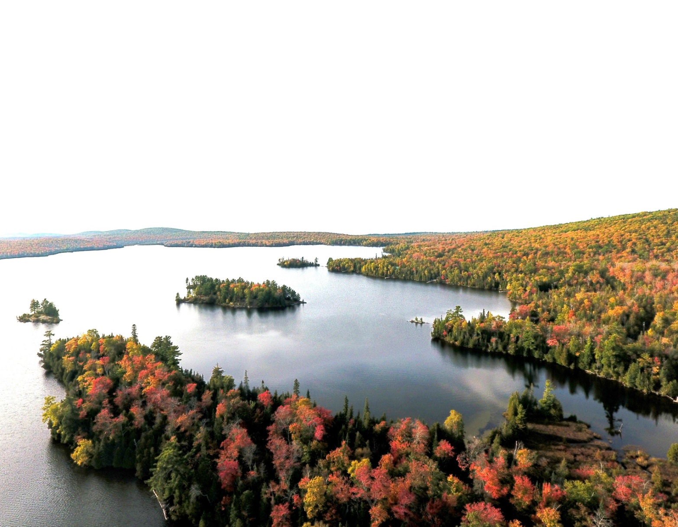
Lake Medora in the Keweenaw Peninsula. Much of the surrounding forestland is part of the Keweenaw Heartlands property that was protected in 2022. © Mark R. Upton Photography
COPPER HARBOR, Mich. – On Wednesday, Aug. 21, The Nature Conservancy in Michigan (TNC) held a Keweenaw Heartlands Project update to bring the public up to speed on the latest with the project. TNC was joined by representatives from the Michigan Department of Natural Resources (MDNR) at the meeting.
“I appreciate everyone who came out to hear the latest update on the Keweenaw Heartlands project and for your thoughtful and candid questions,” said Julia Petersen, Keweenaw Heartlands project manager for The Nature Conservancy in Michigan. “We have been working closely with the community since our last update to lay the foundation for local management and governance of the Heartlands and we look forward to continuing that work into 2025.”
TNC provided updates on the development of a local governance entity while MDNR provided an update on its plans to purchase just over 10,000 acres of the Heartlands.
“We’re looking forward to meeting with the public and sharing information about the general management plan process for the portion of the Keweenaw Heartlands the DNR will eventually be purchasing,” said Tori Irving, Upper Peninsula Field Analyst for the Michigan Department of Natural Resources. “Your input on our plans is a critical next step in this process and we look forward to connecting with the community to learn and hear their thoughts.”
The land the DNR plans on purchasing is adjacent to the Fort Wilkins Historic State Park and will allow the State of Michigan to expand on a host of outdoor recreation offerings at the tip of the Keweenaw.
The public update meeting was the first in a series of Heart the Heartlands events offered as summer turns to fall. The update is followed by a hike, open to the public, on Thursday, Aug. 22, from 3-6 p.m. The hike will take attendees up to the Helmut & Candis Stern Preserve at Mt. Baldy. The hike up Mt. Baldy, co-hosted by the Keweenaw Hiking Trails Association. A second hike, Saturday, Aug. 24, from 10:00 a.m. to 1:00 p.m. will take hikers from forest to the rocky shoreline of TNC’s Mary MacDonald Preserve at Horseshoe Harbor.
Registration is required for both events. You can register for the hike at Mt. Baldy here and the hike at Mary MacDonald here.
The Nature Conservancy (TNC) purchased the Keweenaw Heartlands, which includes more than 32,000 acres of land, in two separate sales, one closing in late October 2022 and the second just before Christmas 2022.
While in TNC ownership, the land remains open to the public under the Michigan Commercial Forest Program and on community tax rolls. TNC, as the temporary owner before these lands are in public ownership, is working closely with the region’s communities to plan for the future of the Heartlands and ensure long-term protection of this forest wildlife and people.
You can find more information about our “Heart the Heartlands” series and view upcoming events on our event poster, or learn more about the Keweenaw Heartlands project here.
The Nature Conservancy is a global conservation organization dedicated to conserving the lands and waters on which all life depends. Guided by science, TNC works to create innovative, on-the-ground solutions to the world’s toughest challenges so that nature and people can thrive together. Learn more online at nature.org/michigan and connect with us on Facebook, Instagram, LinkedIn and TikTok.
# # #

