
http://www.michigan.gov/MeetUpEatUp
Houghton Elementary Schools
Free Curbside Meal Pick Up Summer 2024
203 W. Jacker Ave. Houghton, MI 49931

Free breakfasts and lunches can be picked up for children under 18 years old OR with special needs up to age 26 and enrolled in school for the week- on Wednesday, June 12, 19, and 26, July 3, 10, 17, 24, and 31, August 7, 14, and 21 from 3:30pm-6:30pm.
Please sign up to participate.

Pick up will be at Houghton Elementary School on 203 W Jacker Ave in the bus lane. If you require special allergy meals, you will need a form filled out by a doctor.
Forms are available upon request.

If you have any questions call or email Shelby Turnquist:
906-369-0449 sturnquist@hpts.us

SIGN UP LINK: https://forms.gle/46RnYEuE3AhwHj2R7
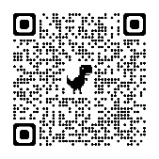
This institution is an equal opportunity provider

