
http://www.michigan.gov/MeetUpEatUp
Hancock Elementary Schools
Free Curbside Meal Pick up
1201 N. Elevation St. Hancock, MI 49930

Free breakfasts and lunches can be picked up for children under 18 years old OR with special needs up to age 26 and enrolled in school for the week- on Tuesday, June 11, 18, and 25, July 2, 9, 16, 23, and 30, August 6, 13, and 20 from 3:30pm-6:30pm.
Please sign up to participate.

Pick up will be at Hancock Elementary School in the bus lane on 1201 North Elevation Street. If you require special allergy meals, you will need a form filled out by a doctor.
Forms are available upon request.

If you have any questions call or email Shelby Turnquist:
sturnquist@hancock.k12.mi.us 906-369-0449
SIGN UP LINK: https://forms.gle/ETCG7ht7DZRH8LBy6
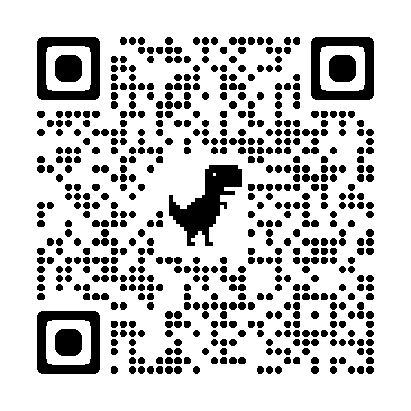
This institution is an equal opportunity provider

