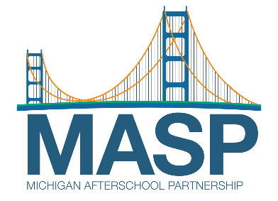

FOR IMMEDIATE RELEASE
January 22, 2024
Media Contact: Craig Fahle, VVK PR + Creative
Email: Craig@vvkagency.com
P: 313 307-6658

Michigan Afterschool Partnership Applauds Governor’s $50 Million Investment in Out-of-School Time Programs
Grant funding sets new precedent for Michigan; thousands of children to benefit from access to after school and out-of-school time programs
The Michigan Afterschool Partnership (MASP) hailed Governor Gretchen Whitmer’s recent announcement of $50 million in grants to support afterschool, out-of-school time, and summer learning programming in Michigan. This unprecedented level of support from the Michigan Department of Lifelong Education, Advancement and Potential (MiLEAP) will go a long way towards MASP’s goal of having high-quality out-of-school time programming available for every student in Michigan.
Statewide, 126 out-of-school time programs are receiving a 2023-24 Out-of-School Time (OST) Grant from MiLEAP in partnership with the Michigan Department of Education. In total, $50 million was awarded to 783 sites to increase the number of kids participating in OST programs and help reduce costs to families.
“We are grateful that the Governor and MiLEAP recognize just how valuable and impactful out-of-school time programs are,” said Erin Skene-Pratt, executive director of MASP. “We know that kids enrolled in out-of-school time programs are more likely to see improvement in their school performance at school and in behavior, and they have a higher earning potential as adults. OST programs also help parents sustain employment and provide parents with peace of mind knowing their children are safe and cared for before and after school, as well as over the summer.”
Despite the increase in grants for the current year, there is still a need for sustained, consistent funding for out-of-school time programs. In Michigan, for every youth in an afterschool program, 4 more are waiting to get in, leaving more than 750,000 youth in our state on the waitlist for an available spot. There are 376 kids for every program in Michigan, and the need is far greater in some communities like Wayne County, where the ratio is 452 to 1. Uneven funding and insufficient staffing remain key barriers to offering these services that are critical for Michigan families.
For the more than 655,500 ALICE (asset limited, income constrained, employed) school-age youth and their families the costs of before school, afterschool and summer programs are often beyond their financial reach. Families across the state report that the gap between work and school schedules can be up to 25 hours per week. Parental concerns about afterschool care result in missed work time and decreased productivity that costs U.S. business up to $300 billion annually.
Among Michigan parents, 77% also report that the availability of nutritious foods is an important factor when choosing their program. It’s the OST programs in communities that are often providing meals to students when schools aren’t in session. With more than 282,320 children in Michigan who are food insecure, the snacks and meals served at OST programs are critical to addressing hunger in the state.
“Before- and after-school programs allow kids to explore interests, get help with schoolwork, connect with peers and put them on a path to success,” said Michelle Richard, acting director of the Michigan Department of Lifelong Education, Advancement and Potential (MiLEAP). “MASP plays a key role in expanding access to these critical programs, and we look forward to working with them to ensure every student gets the support they need to succeed.”

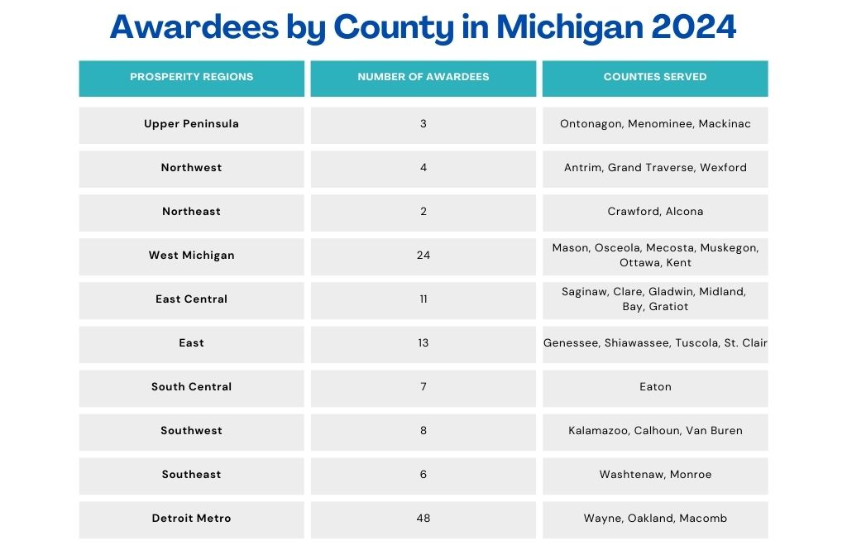
A comprehensive list of awardees can be found here.
###
About Michigan Afterschool Partnership:
MASP is a statewide network dedicated to strengthening the quality of Michigan’s out-of-school time (OST) programs and ensuring that every student who wants to participate has that opportunity. We bring together resources, expertise, and best practices to support OST providers across our state. Our partners include Boys & Girls Clubs, YMCAs, 4-H centers, libraries, recreation centers, businesses, parks, schools and colleges, summer camps, faith-based organizations, and other community organizations. https://www.miafterschool.org/

